Lecture 07: Specification Sheet

Topic: Drop-down Menu using Semantic Navigation

🎯 Learning Objectives
After completing this lecture, learners will be able to:
- Understand the use of the <nav> semantic element
- Create a navigation menu using <ul>, <li>, and <a>
- Build a basic drop-down menu using HTML & CSS
- Apply hover effects for interactivity

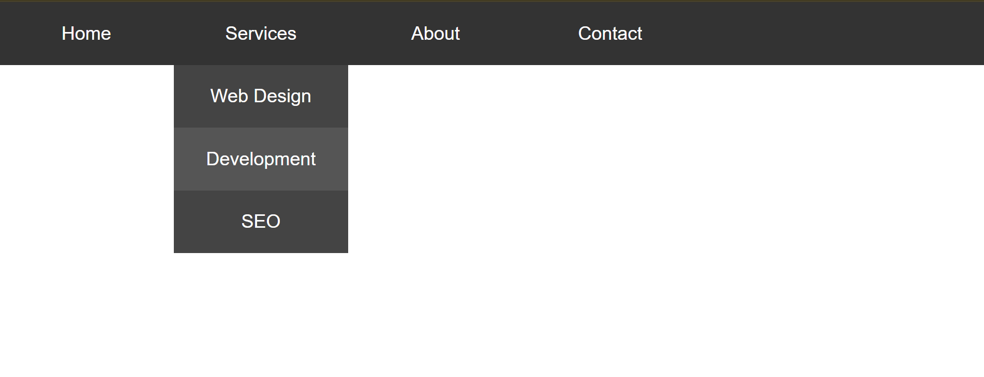

Basic Structure

1. Semantic Navigation (<nav>)
- Used to define a navigation section
- Improves accessibility and SEO

2. List Structure
- <ul> → Unordered list (menu container)
- <li> → List item (menu item)
- <a> → Anchor tag (link)

HTML Structure Example (nav>ul.menu>(li>a{Home})*4)
<nav>
<ul class="menu">
<li><a href="#">Home</a></li>

<li>
<a href="#">Services</a>
<ul class="dropdown">
<li><a href="#">Web Design</a></li>
<li><a href="#">Development</a></li>
<li><a href="#">SEO</a></li>
</ul>
</li>

<li><a href="#">About</a></li>
<li><a href="#">Contact</a></li>
</ul>
</nav>

🎨 CSS Specification

1. Reset Default Styles
* {
margin: 0;
padding: 0;
box-sizing: border-box;
}

2. Style Navigation Menu
.menu {
list-style: none;
display: flex;
background-color: #333;
}

3. Style Menu Items
.menu li {
position: relative;
}

.menu a {
display: block;
padding: 15px 20px;
color: white;
text-decoration: none;
}

4. Hover Effect
.menu li:hover {
background-color: #555;
}

🔽 Drop-down Menu Design

Hide Drop-down Initially
.dropdown {
display: none;
position: absolute;
background-color: #444;
list-style: none;
top: 100%;
left: 0;
}

Show Drop-down on Hover
.menu li:hover .dropdown {
display: block;
}

Style Drop-down Items
.dropdown li a {
padding: 10px 20px;
}

⚙️ Key Concepts
- Positioning
  - Parent <li> → position: relative
  - Drop-down <ul> → position: absolute
- Hover Control
  - li:hover .dropdown shows submenu
- Nested Lists
  - Drop-down menus are nested <ul> inside <li>

🧪 Expected Output
- Horizontal navigation bar
- When hovering on "Services" → drop-down appears
- Clean and responsive menu structure

⚠️ Common Mistakes
- Forgetting position: relative on parent <li>
- Not hiding dropdown using display: none
- Missing nested <ul> structure
- Using margin instead of positioning for dropdown

📌 Best Practices
- Use semantic <nav> for navigation
- Keep menu structure simple and readable
- Use CSS for styling (avoid inline styles)
- Add transition effects for smooth dropdown

📝 Summary
- Navigation menus are built using <nav>, <ul>, <li>, <a>
- Drop-down menus use nested lists
- CSS position and hover are key for functionality

